Topic 7. Sustainable and advanced built environments (12 pt. Leave one line after)

Template for Full Length Paper of Cold Climate HVAC 2015 (14 pt. Bold. Capitalize the First Letter of Keywords)

John Zhai^{1,*}, Moncef Krarti¹, and Lin Duanmu² (12 pt. Use first name, middle initial, and last name format)

¹Department of Civil, Environmental and Architectural Engineering, University of Colorado Boulder, Boulder, Colorado, USA (12 pt.)
²Department of Civil Engineering, Dalian University of Technology, Dalian, China (12 pt. leave one empty line after)

*Corresponding email: coldclimatehvac@gmail.com (12 pt. Leave one empty line after)

Keywords: Maximum five keywords, Capitalize the first word, Separate by a comma (12 pt. Leave one empty line after)

SUMMARY (Times New Roman Bold 12 pt, UPPERCASE, leave a blank line before and after the main level headings)

Prepare an informative summary of up to 150 words for your paper. The summary should provide information on the purpose of the study, methods or procedures, results, discussion and concluding remarks. The summary should be a self-contained statement giving the reader a clear indication of the purpose and content of the paper.

INTRODUCTION

The introduction should present the practical and scientific background for the study or presentation, the hypothesis(es) and a clear statement of the objective(s) of the study/presentation. (Leave one blank line between paragraphs throughout)

Cold Climate HVAC 2015 allows authors to submit only a one-page abstract or a one-page abstract with a full length paper. This instruction is for the full length paper. This file can be used as a template by simply replacing the corresponding text with your own. Please submit this paper in MS word file to hvac@dlut.edu.cn by May 1, 2015 or update it. The paper is required no longer than 8 pages and the author need consider remove those less important information. The conference secretariat will acknowledge when receiving your file(s). If you do not get the confirmation two weeks after your submission, please contact the secretariat to ensure that you files are not lost in the cyber space. Please name the file of this paper as ID.doc, where “ID” is the paper number assigned to you by Cold Climate HVAC 2015. For example, a paper file can look like T6_11.doc.

The maximum length of a full paper is eight pages, including references, figures and tables. Please use A4 paper format when preparing your paper. All margins should be set to 25 mm. Use single column format. All text should be justified using Times New Roman font with 12 pt size. Leave a blank line between paragraphs and before and after a main level heading. Please use 12 pt UPPERCASE bold font for main headings and 12 pt normal lowercase (The first letter capitalized) bold font for 2nd level headings. Avoid use 3rd level headings. Please do not number the pages.

METHODS

This section should describe the study design, materials, measurement methods, and procedures and statistical methods. Measurement and statistical methods should be mentioned, but for routine methods a reference rather than a description of the method is recommended.

The full papers must provide new information on scientific validation, comparative testing, research or development. Commercialism is not allowed.

RESULTS

Please do not simply present results, but provide some overall comments on the findings and their applicability in other settings or applications. You should do the analyses of the results for readers.

Tables and illustrations (Times New Roman Bold 12 pt, Lowercase for 2nd level heading)
In general, figures and other illustrations should be used when they are shorter, clearer, or more effective than explanations in words. Avoid tables and figures that duplicate each other or present superfluous data. If you use a figure, do not include a table for the same information. Substitute a few typical results for lengthy tables when practical. A table must have a suitable caption above it, and a figure must have a caption below it. Use single line border as shown in Table 1. Tables and figures should be inserted in the text near to the place they are mentioned the first time. Please insert figures as ‘picture’ (e.g. wmf or jpg), not as ‘objects’ or spreadsheets. Reduce the resolution of photos and figures to 72 pixels/inch. Do not extend figures or tables beyond the margins. Please do not shrink the figures too small. Your eye resolution is the same for the text in a paragraph or in a figure.
(Leave one blank line before and after tables, figures and equations)

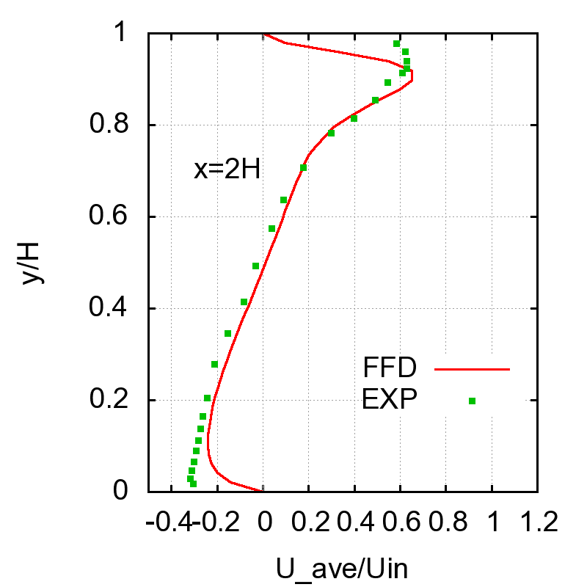
Figure 1. Performance of fast fluid dynamics (FFD) for room airflow prediction (Zuo and Chen 2007)(Italic figure caption)
[leave one blank line between a figure and a table]

Table 1. Performance of the FFD simulations(Italic table caption)
Case | Grids | Δt (s) | N
Channel flow | 64 × 32 | 0.1 | 6.1
Natural convection Convection | 10 × 20 | 0.05 | 25.4
Forced convection | 36 × 36 | 0.5 | 98.6
[leave one blank line between a table and the following text]

Equations
Equations should be numbered at the right margin, as in the example below (Leave one blank line before and after an equation or between equations):

$E[n]=\frac{s_{t}}{{\text{ps}}_{T}}\text{exp}\left(−\frac{1}{2}\frac{(T−m_{T}+L)^{2}}{s_{T}^{2}}\right)t$ (1)

where μ_{T} is the mean value of the temperature and σ_{T} is the standard deviation of the temperature, σ_{t} is the standard deviation of the rate of change of the temperature, and n is the number of level crossings. Use italic symbols for quantities and variables. Punctuate equations with commas or periods when they are part of a sentence.

Names and units
Only use the metric system (SI units). Names of micro-organisms should be italic (e.g. E. coli). Frequently used technical terms may be abbreviated after the first time they are mentioned: “Semi-volatile organic compounds (SVOC) can…”

DISCUSSION

The most important findings of the paper should be put into perspective with prior knowledge. Possible sources of error that may affect the interpretation of the results should also be discussed.

Discussion should also present authors’ interpretation of the meaning of the results. The authors are encouraged to make recommendations on the basis of the earlier knowledge and the present results with special reference practical achievement for well being in indoor environments.

The discussion of implications should tell readers what the importance of the work is for others including researchers, building designers, owners and operators, or occupants.

CONCLUSIONS

The conclusions must be supported by the findings you detailed in the RESULTS section. They should be solid, new, and concise.

ACKNOWLEDGEMENT

You may acknowledge the assistance provided by others to your paper. Sources of financial aid should also be noted.

REFERENCES

Cite the literature by using author and date format, such as a paper published by Zuo and Chen (2007). You could also use the format (Zuo and Chen 2007). Please do not use a comma between name and date. Single author’s name and two authors’ names should be included in the text. For three or more authors, use the last name of the first author with “et al”. For example

.... a feeling of thermal comfort is related to air speed (Hanzawa et al. 1982). ... of such effect were clearly defined (Fanger 1970); however, ...

If the “author” is an organization, use initials. For example

ASHRAE (1992) has used the work from other people (Fanger 1970, 1982; Hanzawa et al. 1982) in its standard….

Do not use blank lines between references. Instead, use a hanging indent of 0.6 cm, as in the examples below. The references should be in alphabetical order.

ASHRAE. 1992. ANSI/ASHRAE Standard 55-1992, Thermal Environmental Conditions for Human Occupancy. Atlanta: American Society of Heating, Refrigerating, and Air-Conditioning Engineers, Inc.
Chen Q. 1988. Indoor airflow, air quality and energy consumption of buildings. Ph.D. Thesis, Delft University of Technology, The Netherlands, 156 pages.
Chen Q. and Wang L. 2004. Coupling of multizone program CONTAM with simplified CFD program CFD0-C. Final Report for NIST RFQ-03-Q-9537, School of Mechanical Engineering, Purdue University, West Lafayette, Indiana, USA, 120 pages.
Fanger P.O. 1970. Thermal Comfort. Copenhagen: Danish Technical Press.
Hanzawa H., Melikov A.K., and Fanger P.O. 1987. Air flow characteristics in the occupied zone of ventilated spaces. ASHRAE Transactions, 93(1), 10-20.
Kimura K. and Tanabe S. 1993. Recommended air velocity against combinations of temperature and humidity for sedentary occupants in summer clothing. In: Proceedings of the 6th International Conference on Indoor Air Quality and Climate – Indoor Air ’93, Helsinki, Finland, Vol. 6, pp. 61-66.
Olesen B.W. 2004. International standards for the indoor environment. Indoor Air, 14(Suppl 7), 18-126.
Zukowska D., Popiolek Z., and Melikov A. 2007. Impact of personal factors and furniture arrangement on the thermal plume above a human body. In: Proceedings of the 10th International Conference on Air Distribution in Rooms - Roomvent 2007, Helsinki, Finland, Vol. 3, pp. 137-144.
Zuo W. and Chen Q. 2007. “Real time airflow simulation in buildings,” Proceedings of the 6th International Indoor Air Quality, Ventilation and Energy Conservation in Buildings Conference (IAQVEC 2007), Sendai, Japan, Vol. 2, pp. 459-466,

